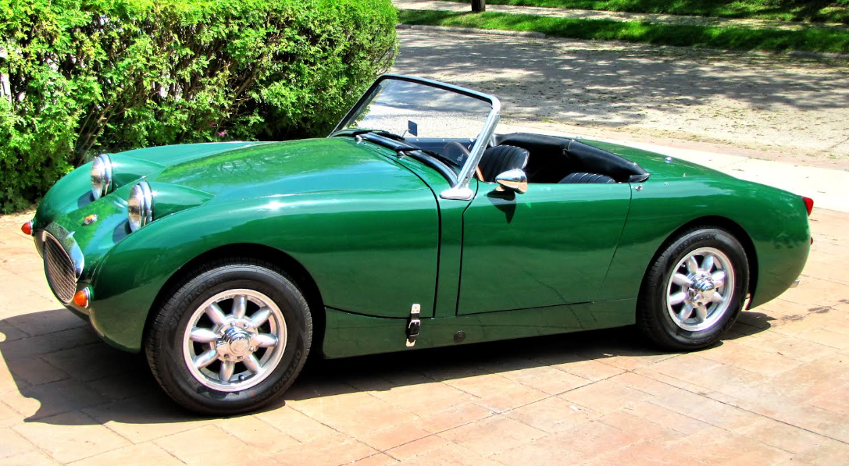
Dennis Zeiger’s 1959 Healey Bugeye

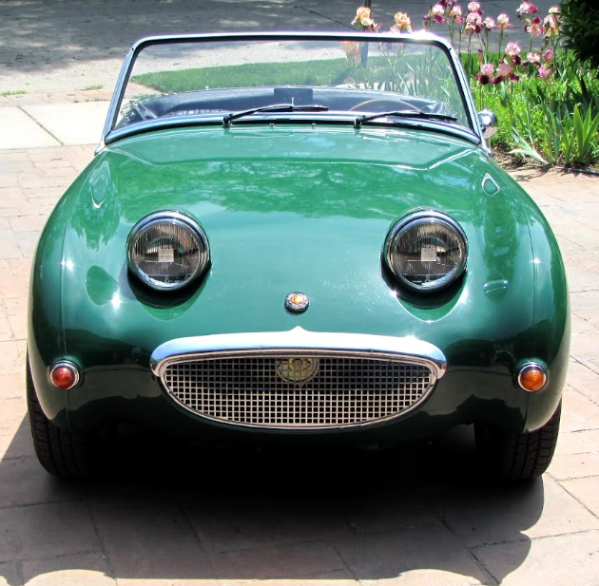
Dennis Zeiger’s 1959 Healey Bugeye

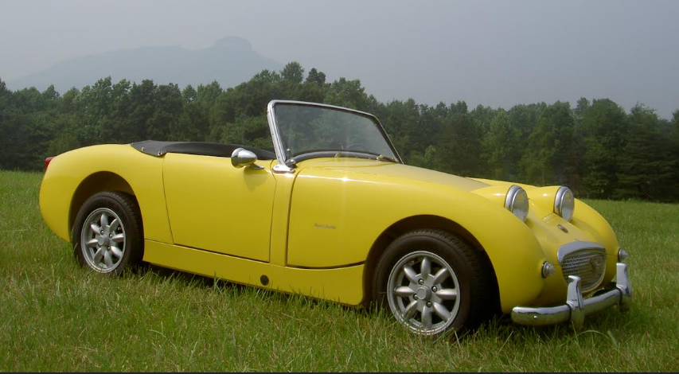
Joe Lambert’s 1959 Healey Bugeye

